***ELEC 300 — Linear Circuits: II — Spring 2018*** ***Name ___________________***



***Assignment 04 — due Monday, 05 Feb 2018, in class*** ***Std #____________________***

**Problem 1**

A coil with a resistance of 5 and inductance 100 mH is connected in series with a capacitor of 50 pF. The circuit is connected to a voltage source that provides 1 V at all frequencies and has an

inner impedance of 50 . Calculate *o*, *Q* and *B*.

**Problem 2**

The parameters of a parallel *RLC* circuit are *R* = 100 k , *L* and *C* = 40 pF. The circuit is

driven by a current source with an inner impedance of 1 M . Calculate the quality factor, the center frequency, and the half power frequencies.

**Problem 3**

Design a parallel *RLC* circuit that has a midband admittance of 25 10-3 S, quality factor of 80, and a resonant frequency of 200 krad/s. Calculate the values of *R*, *L*, and *C*.

**Problem 4**

Find the resonant frequency.

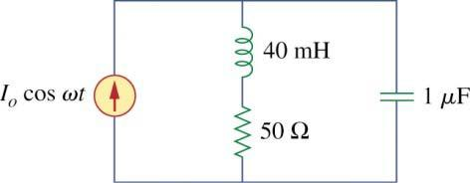

**Problem 5**

Find the transfer functions *H*( ) =*IL*( )/*Is*( ) and determine the relationship between the damping factor and the quality factor *Q*.

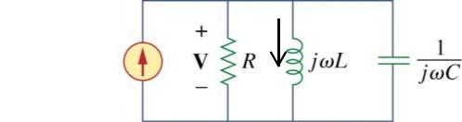

|  |  |  |
| --- | --- | --- |
| *Is* | *IL* |  |
|  |  |

Page 1 of 1